Curriculum Vitae

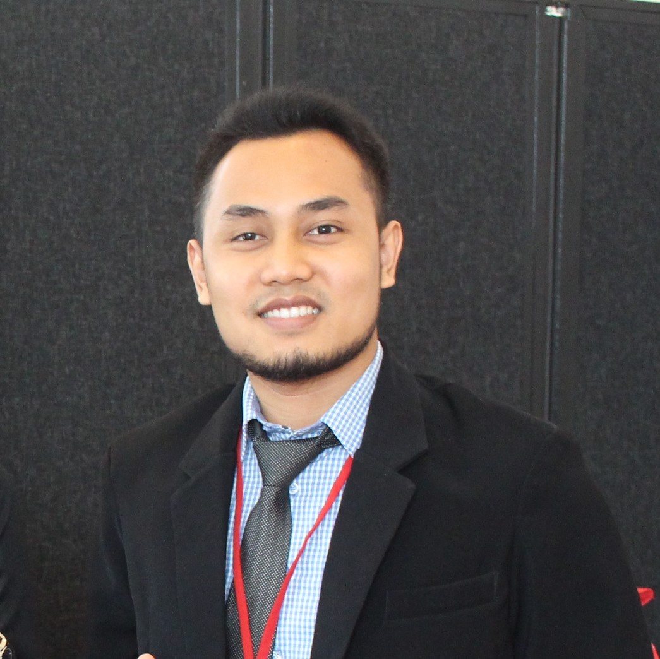
Personal Information
 | Name  Sex  Place & Date of Birth  Nationality  Address  Phone  E-mail  NIDN/NIP  Sinta ID  Scopus ID  Orcid ID  Researcher ID  TOEFL ITP Score | : Abu Amar Fauzi, S.S., M.M.  : Male  : Tulungagung, August 10th, 1988  : Indonesia  : Puri Surya Jaya, Nagoya Regency, G1/21  Ketajen, Gedangan, Sidoarjo  : 082330058438  : abu.amar@perbanas.ac.id  : 0710088804/36170682  : 6001452  : 57204196315  : https://orcid.org/0000-0003-0693-6814  : http://www.researcherid.com/rid/L-3683-2018  : 513 (April 2018)
Career Objective
To gain global exposure and experience as a lecturer on marketing fields and thereby secure a challenging position where I can effectively contribute my skills as a professional lecturer. I give the assurance to employ all of my honesty, dedication, sincerity and skills to promote my institution and I believe, it will undoubtedly help my institution on its way up.

Education
 | 2008 – 2012  2014 – 2016 | : Universitas Negeri Malang, English Linguistics (S1)  : STIE Perbanas Surabaya, Master of Management (S2)
Organization Experiences
- Secretary of Postgraduate Student Association, STIE Perbanas Surabaya, 2015 – 2016
- Secretary of Cooperation Division, East Java’s Indonesian Bankers Club, 2017 – 2022

Work Experiences
- Banking Staff of Mas Mansyur Surabaya Branch, PT Bank Muamalat Indonesia Tbk, 2013 – 2017
- Junior Lecturer of STIE Perbanas Surabaya, 2017 – Now
- Head of Marketing and Public Relations of STIE Perbanas Surabaya, 2018 – Now

Certifications
- Asset Valuation I, MAPPI, (Certified), 2016
- Risk Management Level I, (Certified), 2017
- Funding Sales Representative, (Certified), 2018

Research Grants
- Electronic Service Quality on Application-Based Service of Online Transportation Services in Indonesia, 2017, STIE Perbanas Surabaya
- Financial Literacy and Performances Improvement of Micro Small Medium Enterprises, 2017, STIE Perbanas Surabaya
- E-Toll Adoption in Indonesia, Does Institutional Theory Exist There?, 2017, STIE Perbanas Surabaya
- Why the Indonesian People Use Mobile Transportation Application More? The Exploration of Personal Innovativeness, Number of Peers towards Perceived Value and Continuance Intention, 2018, STIE Perbanas Surabaya

Community Services
- Interviewees of Radio Interactive Talkshow at MNC Trijaya Radio 104.7 FM discussion on “Improving Market Share of Indonesian Islamic Banks through an Effective Marketing”, December 6th, 2017
- Interviewees of Radio Interactive Talkshow at MNC Trijaya Radio 104.7 FM discussion on “Social Media Advertisement: Promotion Channel Solution for MSMEs (Micro Small Medium-sized Enterprises)”, July 4th, 2018

Publications
- Electronic Service Quality on Mobile Application of Online Transportation Services; Jurnal Manajemen Indonesia, Volume 8 No. 1, April 27th, 2018
- Financial Literacy and Business Performances Improvement of Micro, Small, Medium-sized Enterprises (MSMEs) in East Java Province, Indonesia; International Journal of Education Economics and Development, Volume 9 No. 4, November 6th, 2018
- Measuring the Effects of Service Quality by Using CARTER model towards customer satisfaction, trust and loyalty in Indonesian Islamic Banking, Journal of Islamic Marketing, in Press

Awards
- Outstanding Paper Award from International Journal of Business and Society (IJBS), Universiti Sarawak Malaysia on The 5th International Conference on Business and Banking, August 2nd -3rd, 2018
- 10 Best Paper on East Java Economic Forum (EJAVEC) 2018 from The East Java Representative of Indonesian Central and Airlangga University, November 14th -15th, 2018

Peer Review of Journal Experiences
- Asia Pacific Journal of Marketing and Logistics, June 2018
- Asia Pacific Journal of Marketing and Logistics, December 2018
- Asia Pacific Journal of Marketing and Logistics, February 2019
- Asia Pacific Journal of Marketing and Logistics, February 2019

